**Project Planning Phase**

**Project Planning Template (Product Backlog, Sprint Planning, Stories, Story points)**

|  |  |
| --- | --- |
| **Date** | **20 October 2022** |
| **Team ID** | **PNT2022TMID32468** |
| **Project Name** | **IOT Based on Smart Crop Protection System For Agriculture** |
| **Maximum Marks** | **8 Marks** |

**Product Backlog, Sprint Schedule, and Estimation (4 Marks)**

# Use the below template to create product backlog and sprint schedule

|  |  |  |  |  |  |  |
| --- | --- | --- | --- | --- | --- | --- |
| **Sprint** | **Functional**  **Requirement (Epic)** | **User Story Number** | **User Story / Task** | **Story Points** | **Priority** | **Team**  **Members** |
| Sprint-1 | Registration | USN-1 | As a user, I can register for the application by entering my email, password, and confirming my password. | 2 | High | BOORNIMA.S |
| Sprint-1 |  | USN-2 | As a user, I will receive confirmation email once I have registered for the application | 1 | High | SRUTHI.S |
| Sprint-1 |  | USN-3 | As a user, I can register for the application through Facebook | 2 | Low | SUSITHRA.N |
| Sprint-1 |  | USN-4 | As a user, I can register for the application through Gmail | 2 | Medium | SOWMIYA.R |
| Sprint-1 | Login | USN-5 | As a user, I can log into the application by entering email & password | 1 | High | SOWMIYA.R |
| Sprint-1 | Dashboard | USN-6 | As a user, I can log into the application by entering email & password and access all the resources and services available | 2 | High | BOORNIMA.S |

|  |  |  |  |  |  |  |
| --- | --- | --- | --- | --- | --- | --- |
| **Sprint** | **Total Story Points** | **Duration** | **Sprint Start Date** | **Sprint End Date (Planned)** | **Story Points**  **Completed (as on**  **Planned End Date)** | **Sprint Release Date (Actual)** |
| Sprint-1 | 20 | 6 Days | 24 Oct 2022 | 29 Oct 2022 | 20 | 29 Oct 2022 |
| Sprint-2 | 20 | 6 Days | 31 Oct 2022 | 05 Nov 2022 |  |  |
| Sprint-3 | 20 | 6 Days | 07 Nov 2022 | 12 Nov 2022 |  |  |
| Sprint-4 | 20 | 6 Days | 14 Nov 2022 | 19 Nov 2022 |  |  |

|  |  |  |  |  |  |  |
| --- | --- | --- | --- | --- | --- | --- |
| **Sprint** | **Functional**  **Requirement (Epic)** | **User Story Number** | **User Story / Task** | **Story Points** | **Priority** | **Team Members** |
| Sprint-2 | Login | USN-1 | As a weather data controller, I log into my profile and start monitoring the weatherupdates | 3 | High | SRUTHI.S |
| Sprint-2 | Dashboard | USN-2 | I receive all the information about weather from web from weather API. Whenever there is change in weather, corresponding updates are made on sign boards. | 2 | Medium | SUSITHRA.N |
| Sprint-3 | Login | USN-1 | As a image controller, I keep note of all the images received from various areas and detect traffic in that particular area. | 3 | High | SOWMIYA.R |
| Sprint-3 | Dashboard | USN-2 | With the traffic, updates I change the status of sign board as “take diversion”. | 2 | Medium | BOORNIMA.S |
| Sprint-4 | Login | USN-1 | With the traffic, updates I change the status of sign board as “take diversion With the traffic, updates I change the status of sign board as “take diversion | 3 | High | SUSITHRA.N |
| Sprint-4 | Login | USN-1 | As an administrator, I ensure that all departments work co-ordinated and ensure the accuracy and efficiency. | 2 | Medium | SRUTHI.S |

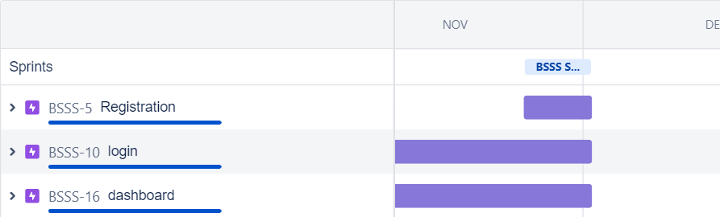

**Project Tracker, Velocity & Burndown Chart: (4 Marks)**

**Velocity:**

# Imagine we have a 10-day sprint duration, and the velocity of the team is 20 (points per sprint). Let’s calculate the team’s average velocity (AV) per iteration unit (story points per day)

